**ASSIGNMENT-2**

**Q1. WAP to find the roots of a quadratic equation.**

#include <math.h>

#include <stdio.h>

int main() {

double a, b, c, d, root1, root2, realPart, imagPart;

printf("Enter coefficients a, b and c:\n");

scanf("%lf %lf %lf", &a, &b, &c);

d = b * b - 4 * a * c;

if (d > 0) {

root1 = (-b + sqrt(d)) / (2 * a);

root2 = (-b - sqrt(d)) / (2 * a);

printf("root1 = %.lf and root2 = %.lf", root1, root2);

}

else if (d == 0) {

root1 = root2 = -b / (2 * a);

printf("Roots are real and Equal\n root1 = root2 = %.lf;", root1);

}

else {

realPart = -b / (2 * a);

imagPart = sqrt(-d) / (2 * a);

printf("Roots are not real.\n root1 = %.lf+%.2lfi and root2 = %.f-%.2fi", realPart, imagPart, realPart, imagPart);

}

return 0;

}

**OUTPUT-**

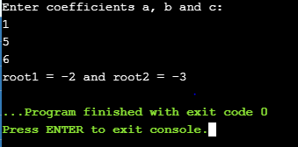

**Q2. Write a menu-driven program to enter 10 numbers and perform**

1. **Sorting in ascending order**
2. **Sorting in descending order.**
3. **Locating a number in the array and display its position**

#include <stdio.h>

#include<conio.h>

#include<stdlib.h>

void asc();

void desc();

void search();

int a[100];

int main()

{

int n=10,i, j,choice;

printf("Enter the elements of the array:-\n");

for(i=0;i<10;i++)

{

scanf("%d",&a[i]);

}

while(choice!=4){

printf("\n\n1.Sorting in ascending order\n2.Sorting in descending order\n3.Locating a number in the array and display its position\n4.Exit");

printf("\nEnter your choice:");

scanf("%d",&choice);

switch(choice){

case 1:

asc();

break;

case 2:

desc();

break;

case 3:

search();

break;

case 4:

exit(0);

break;

default:

printf("\nWrong Option!!");

};

}

return 0;

getch();

}

void asc(){

for (int i = 0; i < 10; i++)

{

for ( int j = 0; j < 10; j++)

{ if (a[j] > a[i])

{ int tmp = a[i];

a[i] = a[j];

a[j] = tmp;

}

}

}

printf("\nSorting in Ascending Order : ");

for (int i = 0; i < 10; i++)

{

printf(" %d ", a[i]);

}

}

void desc(){

for ( int i = 0; i < 10; i++)

{

for (int j = 0; j < 10; j++)

{

if (a[j] < a[i])

{

int tmp = a[i];

a[i] = a[j];

a[j] = tmp;

}

}

}

printf("\nSorting in Descending Order : ");

for (int i = 0; i < 10; i++)

{

printf(" %d ", a[i]);

}

}

void search()

{ int Search,key,i,f;

printf("\nEnter element to search: ");

scanf("%d",&Search);

f = 0;

for(i=0; i<10; i++)

{

if(a[i] == Search)

{

f = 1;

break; }

}

if(f == 1){

printf("\n%d is found at position %d", Search, i + 1);

}

else{

printf("\n%d is not found in the array",Search);

}

}

**OUTPUT-**

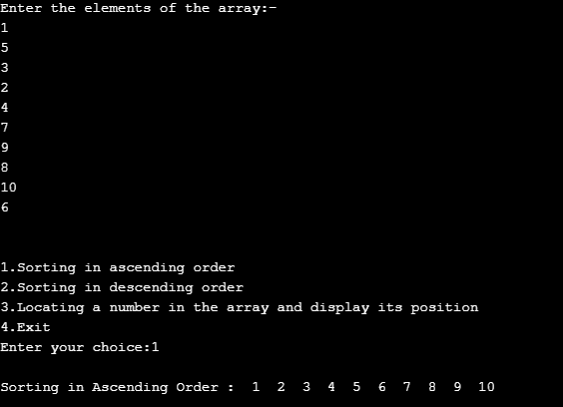

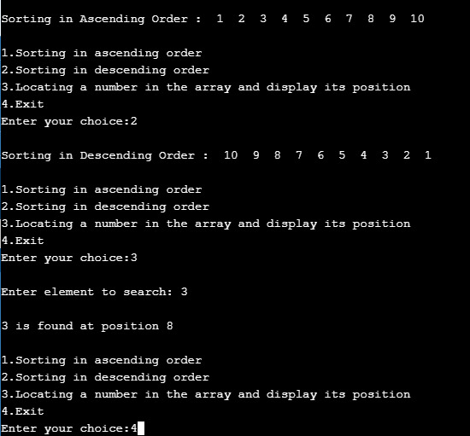

**Q4. Write a program to evaluate n- degree polynomial at some particular value using a user-defined function. The degree of the polynomial has to be entered by the user.**

**Also, include a function to evaluate the d/dx of the polynomial at some value entered by the user.**

#include<stdio.h>

#include<conio.h>

#include<math.h>

#include<stdlib.h>

int eval(int [],int,int);

int deriv(int a[], int n, int x);

int main()

{

int a[10],n,x,i,e,dy1;

printf("\nENTER THE DEGREE OF POLYNOMIAL=");

scanf("%d",&n);

printf("\nENTER THE CO-EFFICIENT OF POLYNOMIAL:-");

for(i=n;i>=0;i--)

{

printf("\nCO-EFFICIENT OF A[%d]= ",i);

scanf("%d",&a[i]);

}

printf("\n\nENTERED POLYNOMIAL IS= \n\n");

for(i=n;i>0;i--)

{

if(a[i]!=0){

printf("%dX^%d+",a[i],i);

}

}

printf("%d",a[i]);

printf("\n\nENTER THE VALUE FOR X=");

scanf("%d",&x);

e=eval(a,n,x);

dy1 = deriv(a,n,x);

printf("\nEvaluation of Polynomial is=%d",e);

printf("\n\nThe value of the derivative of the polynomial equation at x =%d is:%d",x,dy1);

getch();

}

int eval(int a[],int n,int x) **//function for evaluating polynomial**

{

int sum=0,i;

for(i=n;i>=0;i--)

{

sum=sum+a[i]*pow(x,i);

}

return sum;

}

int deriv(int a[], int n, int x) **//function for evaluating derivative of the polynomial**

{

int d[10], pd = 0, ps;

int i;

for(i=0;i<=n;i++)

{

ps = pow(x, n-(i+1));

d[i] = (n-i)*a[n-i]*ps;

pd = pd + d[i];

} return pd;

}

**OUTPUT-**

